Yoo Min Cha
91.413
Professor Chen
Programming 1

For the HTTP server and client programming assignment, I started building my server and client by creating basic TCP protocol end to end sockets, one being the server and the other being the client. I used the Unix API and utilized the addrinfo structure for my client and used sockaddr_in for my server. I started off by basically just having the server listen for incoming calls on the socket assigned with an ip address and a port number. The client then would try to connect to this server on the localhost and port number. After the server has accepted the connection to the client, the server would create a new file descriptor for the client. After this new file descriptor has been created, I have a two way sequenced reliable connection-based stream between the two sockets. I was able to write from the client and have the server display anything was read in from its socket.
I then added more functionality to the client and server. I started off by working on the PUT requests for both the client and the server. Knowing the name of the file on the client side, I opened a file descriptor to the file and read in from the file while simultaneously writing to the socket which would send the data to the server and then the server would read in from its socket continuously. I decided it would be a good idea for the server to create its own writeable file into which it would store the data coming from the client. After the server had received the entire file and saved it, it would send back a response to the client informing it that the file was successfully transferred. After I got this working I decided to move on to the GET requests for the client and the approach was slightly different. I had to create a new request string using sprintf and then sending the request to the server. I would then read in from its socket after sending the GET request because I knew data would be sent from the server after the request has been sent. I also decided it would be a good idea to store the data coming in to a file so that I could open the file and see if the requested file was the one I was looking for. I tested this on the cnn.com server and requested the index. I got a 404 error stating that the file was not found but it also sent me an html file that worked and loaded up in the browser and proved that the GET file was working. I then had to get the GET request to work for my own server. I did this by opening the requested file it was found and then sending it back to the client. If the file was not found, I sent back a 404 file not found message and if the file was found I sent back a 200 OK message and the file after the message. I then proceeded to making the server to allow multiple connections by forking off each accepted client. My server only allowed a max of 5 clients queued up at the same time. I wasn't able to test the functionality of this because the file transfers were too fast and I could not run more than 5 clients fast enough to test if the server connection queue would fill up.

Test Cases Below

Here is the output from my GET command from client. The file from the output is saved in the Client folder. I was also able to GET the file from the server. I used the programming1.html and stored on the server side. Running ./client localhost PORTNUMBER GET programmin1.html will retrieve the file from the server. Inputting the wrong file name to server will result in a 404 ERROR.
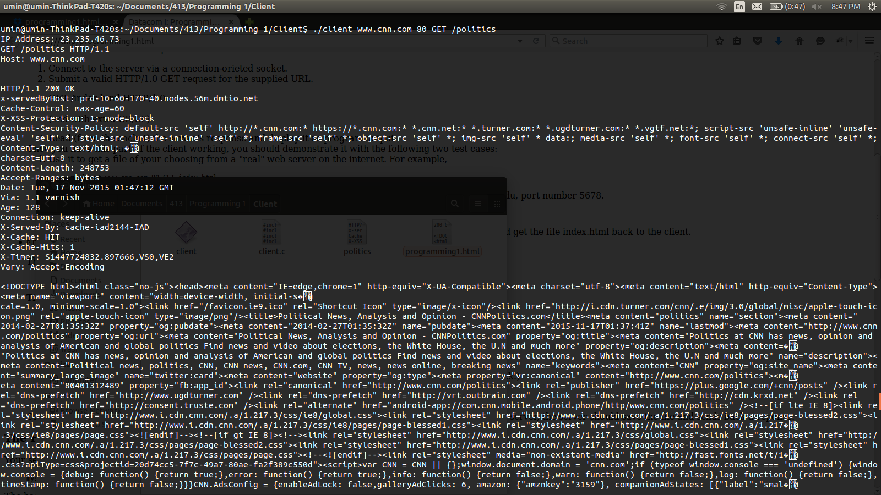

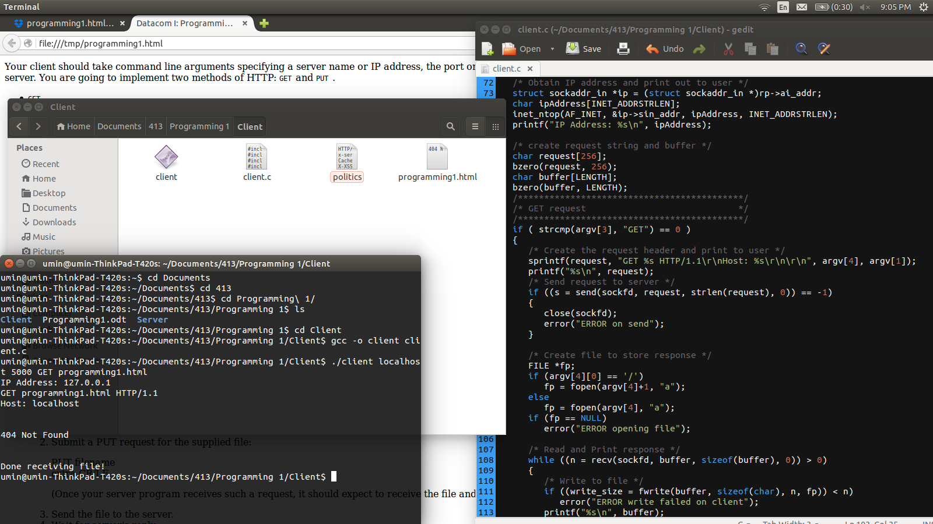

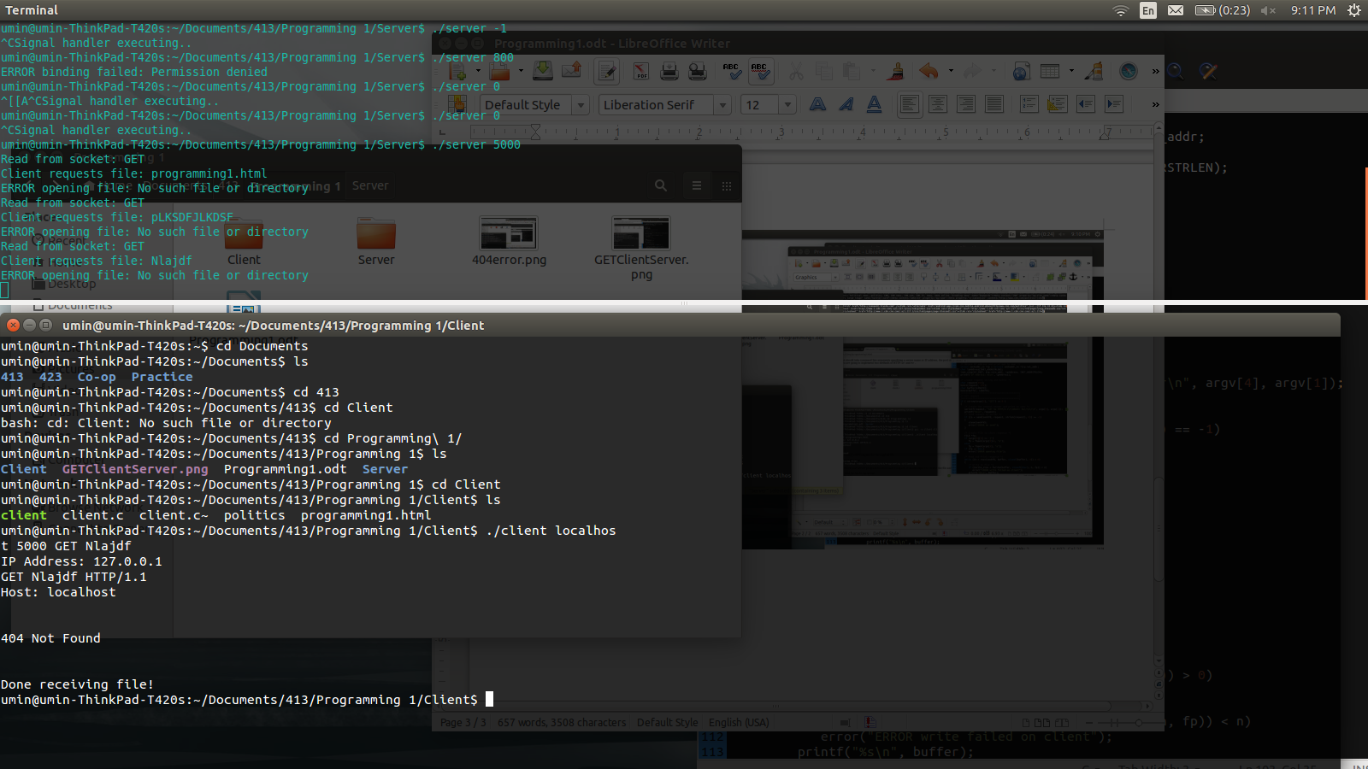

SERVER AND CLIENT PUT REQUEST

